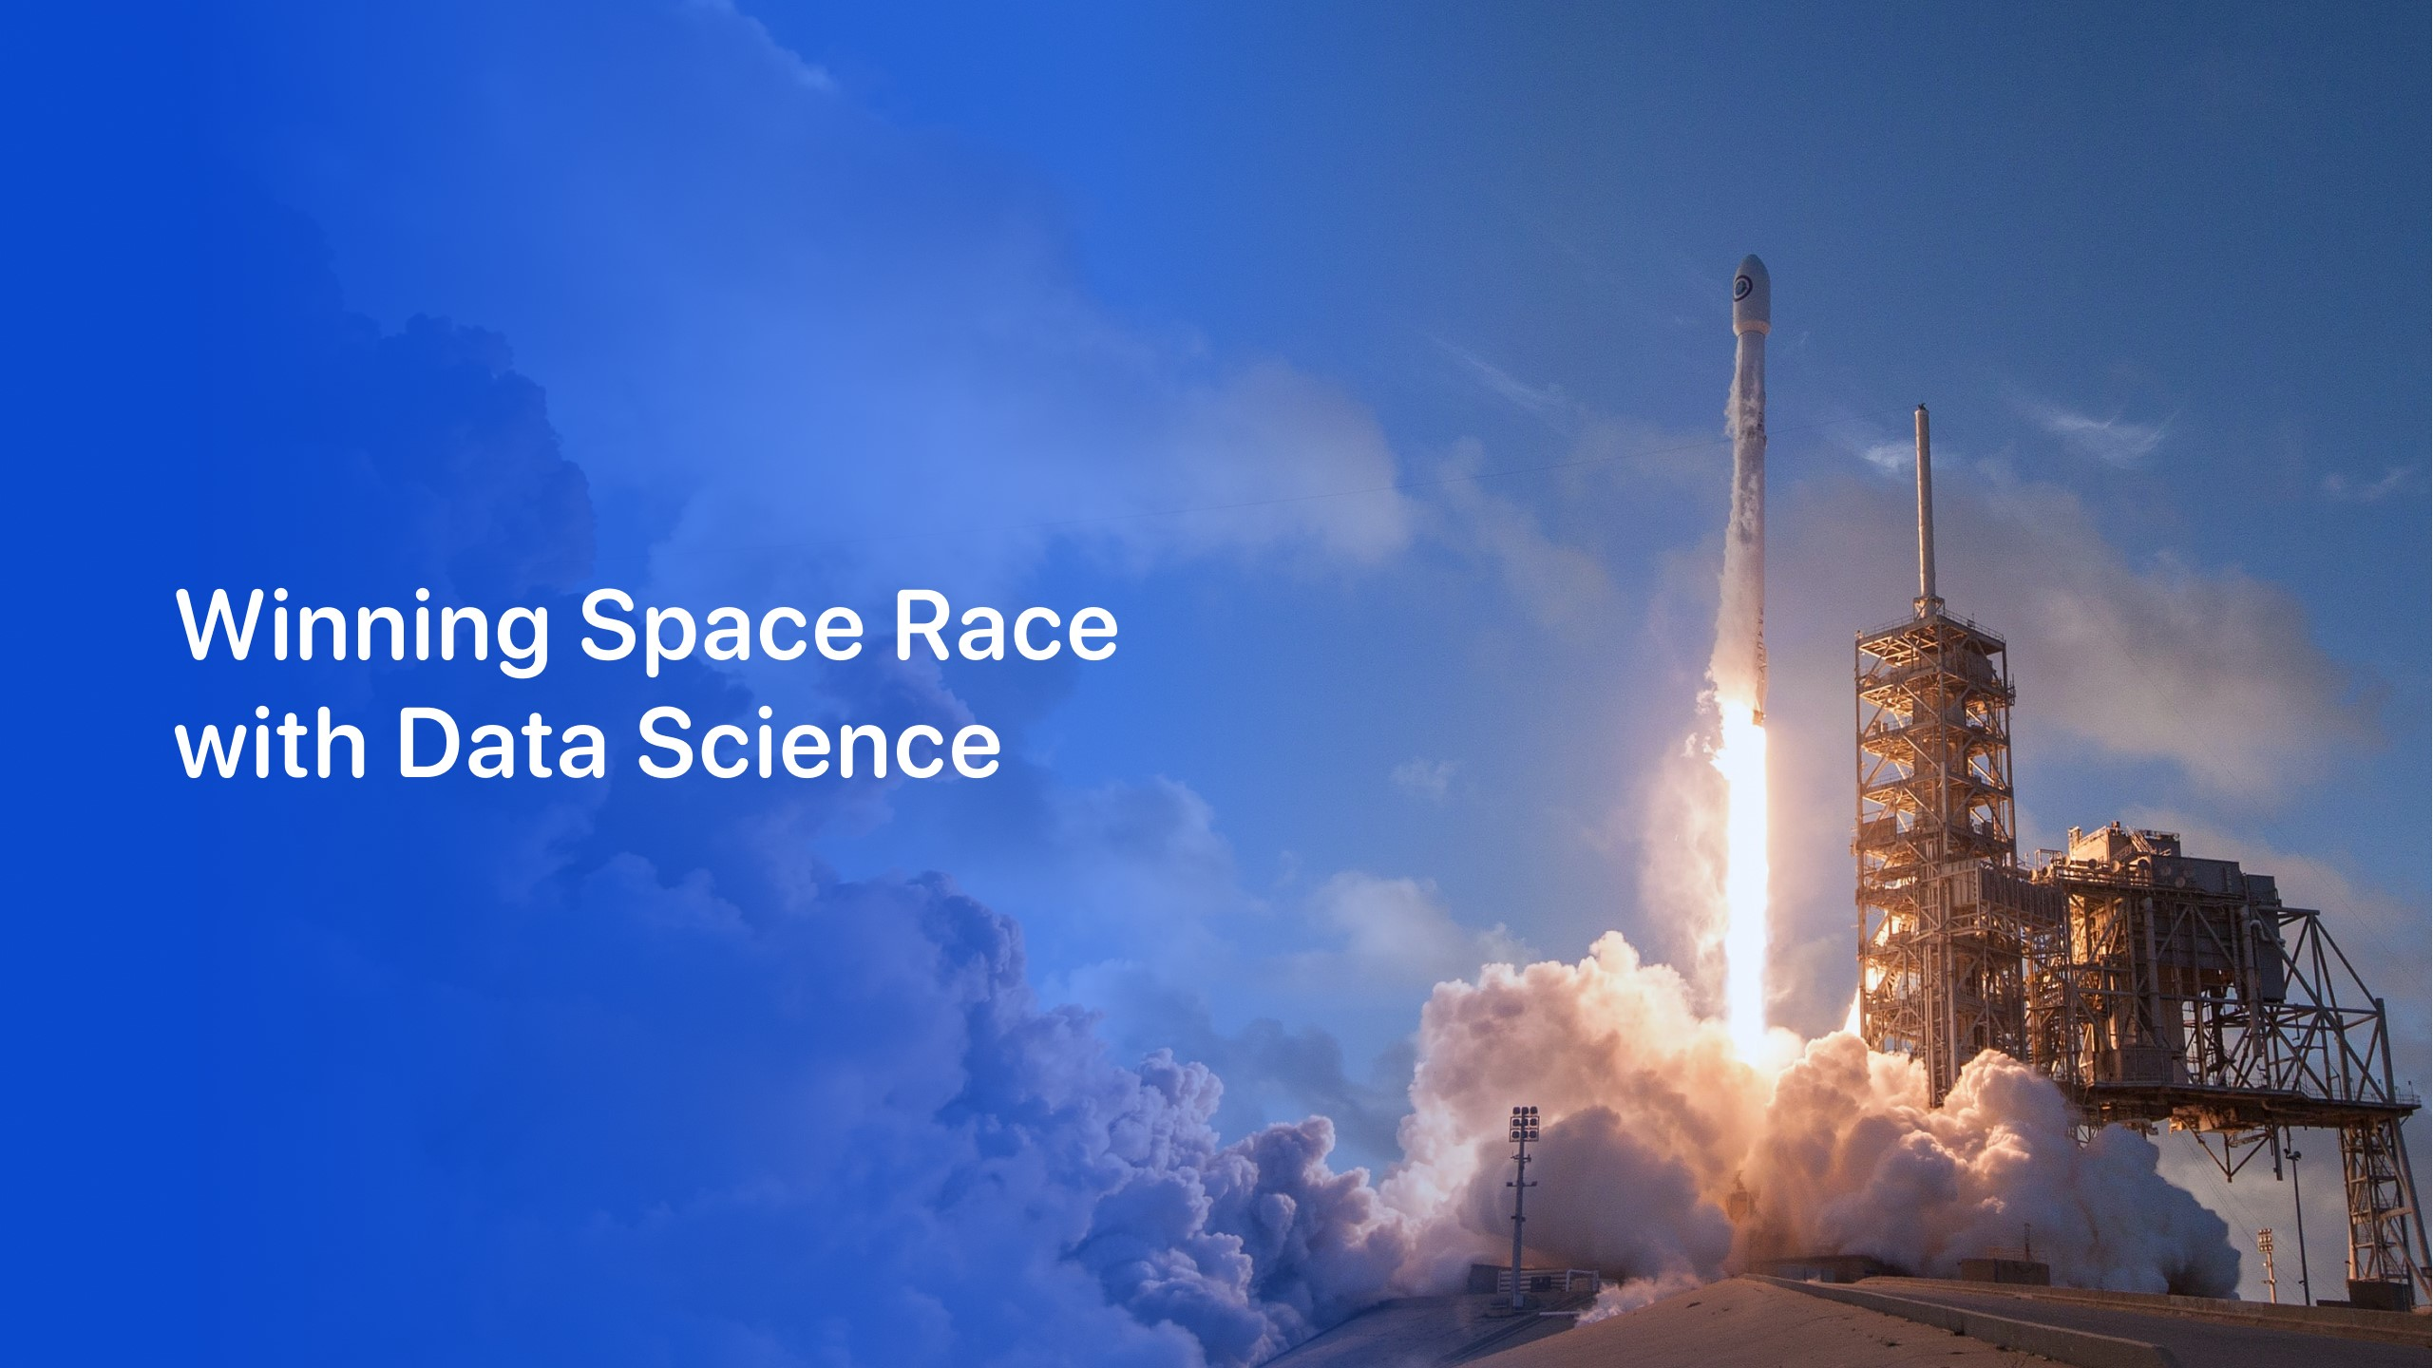

Henil Patel

22 August 2021



•

Executive Summary

•

Introduction

•

Methodology

•

Results

•

Conclusion

•

Appendix

Outline



3

•

Summary of methodologies

•

Data Collection

•

Data Wrangling

•

EDA with Data Visualization

•

EDA with SQL

•

Interactive map with Folium

•

Dashboard with Plotly Dash

•

Summary of all results

•

Reviewing the data analysis results

•

Demo the interactive analytics

•

Reviewing the results

Executive Summary

Introduction

* Project background and context
* From the data collected on the SpaceX web site we predicted if the Falcon 9 rocket launches will land successfully. SpaceX advertises that the Falcon 9 rocket can provide launches at a cost of 62 million USD vs other companies with an average cost near 165 million USD. SpaceX states being able to reuse the first stage of the rocket greatly reduces the launch costs. We will be looking into if the first stage lands. The data can help determine the launch cost for an alterative company looking to compete with SpaceX’ s launch pricing.
* Open Enquiries
* What influences an successful landing?
* Is there an certain variables that effect the rockets landing?
* What conditions need to be achieved to get the best landing results?



5



Executive Summary

•

Data collection methodology:

•

The data was collected from the SpaceX website with a Rest API

•

The API gave us the launch dates, the rocket used, payload, launch location, etc.

•

Perform data

wrangling

•

We are able to remove irrelevant data

•

Perform exploratory data analysis (EDA) using visualization and

SQL

•

Perform interactive visual analytics using Folium and

Plotly

Dash

•

Perform predictive analysis using classification models

•

How to build, tune, evaluate classification models

Methodology



The Collection Process

•

Launch data was collected from the SpaceX website with the REST API

•

The data was filtered to show launches, rocket type, payload, etc.

•

The goal was to use the data to learn if the rocket will land and be reused.

•

The data was collected from the SpaceX REST API

(

api.spacexdata.com/v4/rockets/

)

•

Data was also collected by web scrapping Wikipedia with BeautifulSoup

Data Collection



1.

Check the connection

2.

Get the data in .Json

File

3.

Normalize the .Json

file

4.

Add a dictionary to the data frame

5.

Export to a .cvs

file

•

Here is the process followed

to collect the data from the

.json

file and converted the

relevant data to a .cvs

file

•

Data Collection –

SpaceX API

Use the

SpaceX

REST API

API returns

the data in a

.Json

file

Change

.Json

to a flat

file like .csv

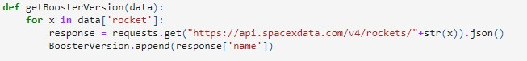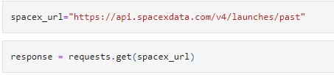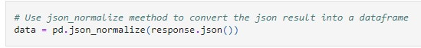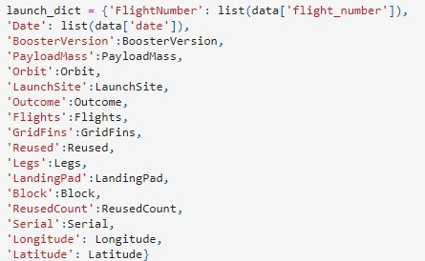

The data on the landings was presented as true or false data if the

booster landed. The data was converted then converted to training

data with 1 representing the booster landed and 0 for if the booster did

not successfully land.

[GitHub URL Fil](https://github.com/aford4141/IBM-Data-Science-Capstone-SpaceX/blob/main/Data%20Collection%20API.ipynb)

[e](https://github.com/aford4141/IBM-Data-Science-Capstone-SpaceX/blob/main/Data%20Collection%20API.ipynb)

Data Wrangling

Find missing Values

Cleaning the

data with

missing

values

Export to .csv

file



The Scatter Plots Generated:

•

Flight Number

vs.

Payload Mass

•

Flight Number vs Launch Site

•

Payload and Launch Site

•

Flight Number and Orbit type

•

Payload and Orbit type

EDA with Data Visualization

Line Graphs:

Launch Success Yearly Trend

Bar Charts:

•

Success Rate of Each Orbit Type

[Get Hub UR](https://github.com/aford4141/IBM-Data-Science-Capstone-SpaceX/blob/main/EDA%20with%20Visualization%20lab.ipynb)

[L](https://github.com/aford4141/IBM-Data-Science-Capstone-SpaceX/blob/main/EDA%20with%20Visualization%20lab.ipynb)

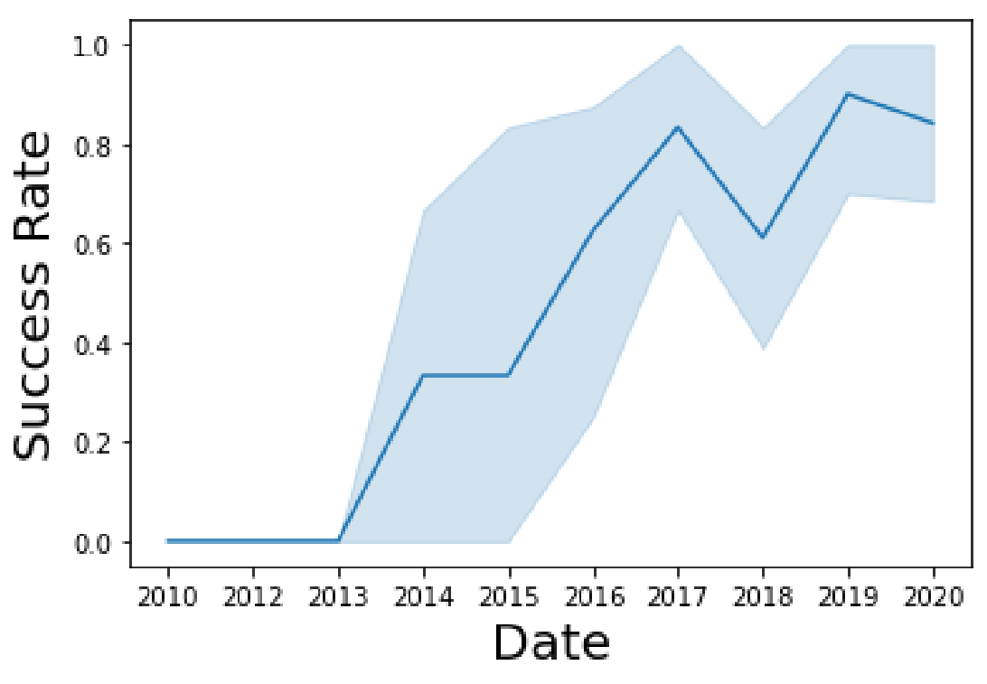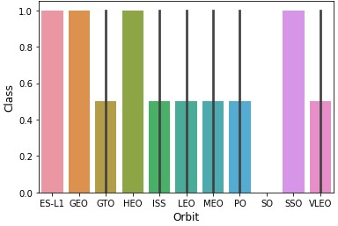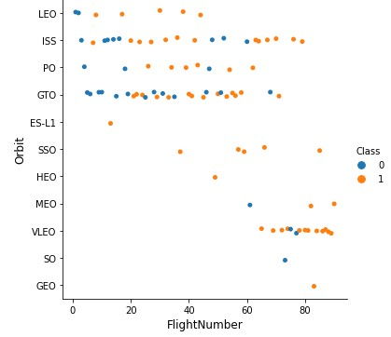

•

Names of the unique launch sites per space mission

•

Display 5 records where Launch site begins with CCA

•

Total play load mass carried by boosters launched by NANA (CRS)

•

Average Payload mass carried by booster F9 v1.1

•

Date when the first successful landing was achieved

•

Name of boosters which have successful drone ship landing with payload mass greater than 4000 but less than

6000

•

Total number of successful and failure mission outcomes

•

Name of booster with maximum payload mass

•

List of failed drone ship landings with booster versions and launch site in 2015

•

Rank the landing outcomes between June 4, 2010 to march 20, 2017 in descending order.

EDA with

SQL



In analyzing the Launch Data an interactive map was created. Using the longitude

and Latitude coordinates of each launch site a circle marker and label was added to

each launch site.

Using the launch data we assigned markers with MarkerCluster() to show the

**Successful (1)**

and

**Failure (0)**

outcomes with

**Green**

or

**Red**

Markers.

We also calculated the distance between landmarks to see if

there was a correlation to landings

**Examples:**

railroads, highways, coastlines, and cities

Interactive Map with Folium

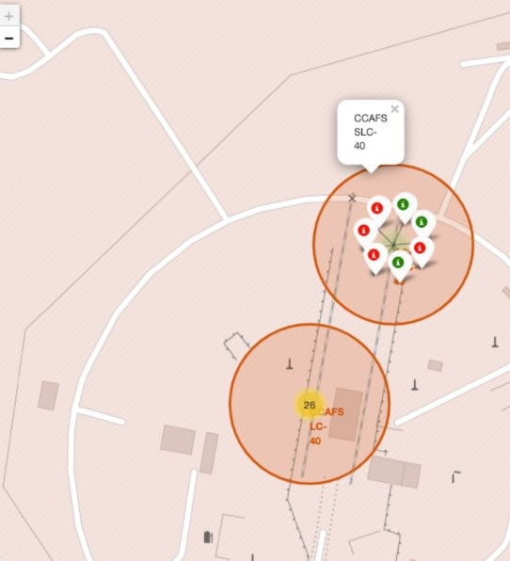

[GitHub Dat](https://github.com/aford4141/IBM-Data-Science-Capstone-SpaceX/blob/main/Interactive%20Visual%20Analytics%20with%20Folium%20lab.ipynb)

[a](https://github.com/aford4141/IBM-Data-Science-Capstone-SpaceX/blob/main/Interactive%20Visual%20Analytics%20with%20Folium%20lab.ipynb)



15

**Building the Model**

1.

The data was loaded into Pandas and NumPy

2.

Data was transformed

3.

Data was split into a training set and test data set

4.

Check the number of test samples were created

5.

Determined the most effective machine learning

logarithm for the dataset

6.

Set parameters and algorithms

7.

Fitted our datasets and trained the data

Predictive Analysis (Classification)

[e](https://github.com/aford4141/IBM-Data-Science-Capstone-SpaceX/blob/main/Machine%20Learning%20Prediction.ipynb)

[GitHub Fil](https://github.com/aford4141/IBM-Data-Science-Capstone-SpaceX/blob/main/Machine%20Learning%20Prediction.ipynb)

**Validating the Model**

1.

Checked the accuracy

2.

Input the hyperparameters for each algorithm

3.

Plotted the Confusion Matrix

**Improving the Model**

1.

Tuning

**Best Preforming Model**

1.

The best preforming model will have the greater accuracy

score.



•

Exploratory data analysis results

•

Interactive analytics demo in

screenshots

•

Predictive analysis results

Results







•

We can see the success

rate has increased over

time at the launch sites

•

CCAFS SLC 40 looks to be

where most test flights

launched.

Flight Number vs. Launch

Site

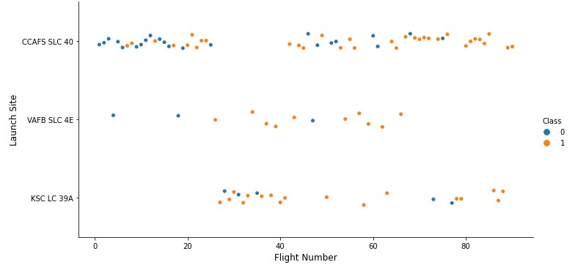

•

The success rate seems to

increase with payloads greater

than 10,000 kg

Payload vs. Launch Site

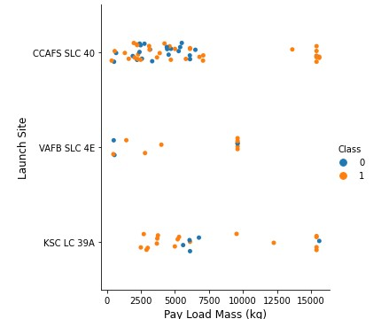

•

ES-L1, GEO, HEO, and

SSO were the orbits with

the highest success rate.

Success Rate vs. Orbit Type

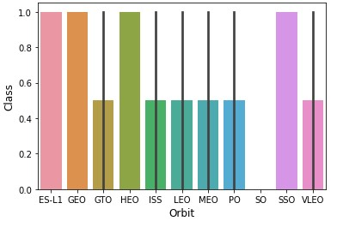

•

Most of the flights seem to

be to ISS, and GTO obits

•

In the later flights there

seems to be an increase on

VLEO obit launches.

Flight Number vs. Orbit Type

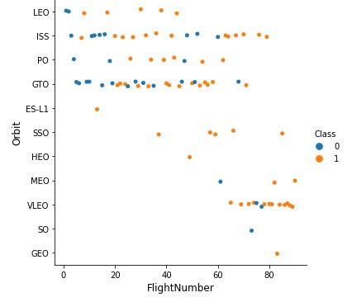

•

Large payloads look to be

launched to VLEO obit

•

Payloads less than 8,000 kg

are mostly sent to GTO and

ISS obits

Payload vs. Orbit

Type

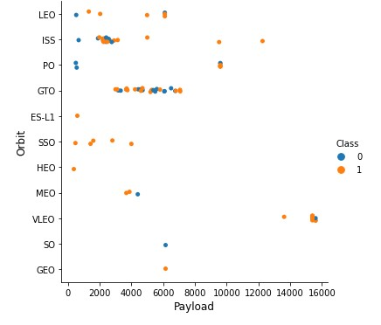

•

The Success Rate has be

steadily increasing over

time.

•

There was a notable

decrease in Success Rate

in 2018.

Launch Success Yearly Trend

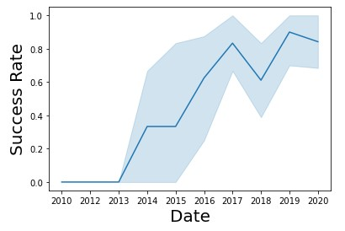

**Query:**

Using the word DISTINCT in the query means that it will only

show Unique values in the Launch_Site

column from tblSpaceX

All Launch Site Names

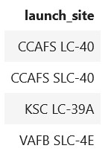

**Query:**

Using the word TOP 5 in the query means that it will only show5 records from

tblSpaceX

and LIKE keyword has a wild card with the words ‘CCA%’ the percentage

in the end suggests that the Launch_Site

name must start with CCA.

Launch Site Names Begin with 'CCA'

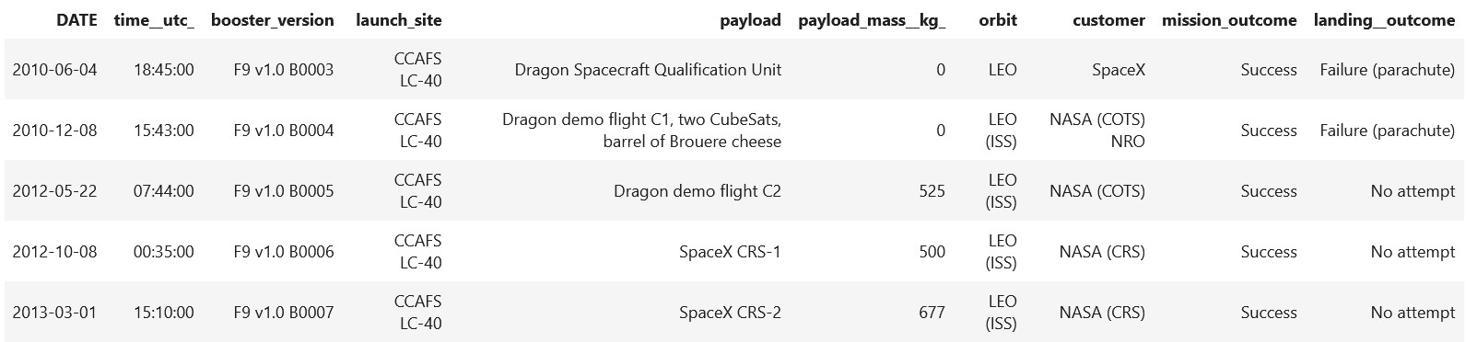

Total payload carried by boosters from NASA

**Query:**

Using the function SUM summates the total in the column

PAYLOAD_MASS_KG_

The WHERE clause filters the dataset to only perform calculations on

Customer NASA (CRS)

Total Payload Mass

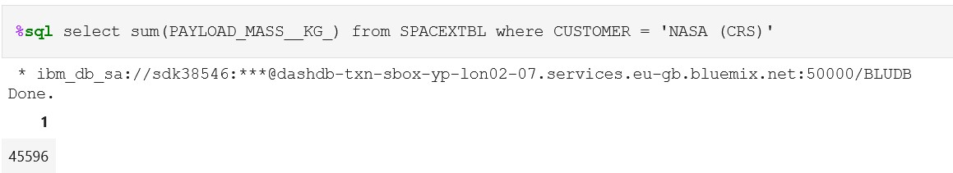

**Query:**

Using the function AVG works out the average in the column

PAYLOAD_MASS_KG_

The WHERE clause filters the dataset to only perform calculations on

Booster_version

F9 v1.1

Average Payload Mass by F9 v1.1

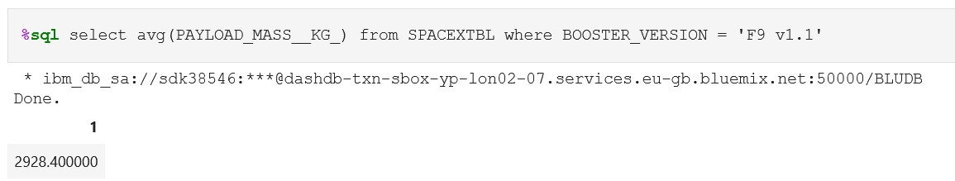

**Query:**

Using the function MIN works out the minimum date in the column Date

The WHERE clause filters the dataset to only perform

calculations on Landing_Outcome

Success (drone ship)

First Successful Ground Landing Date

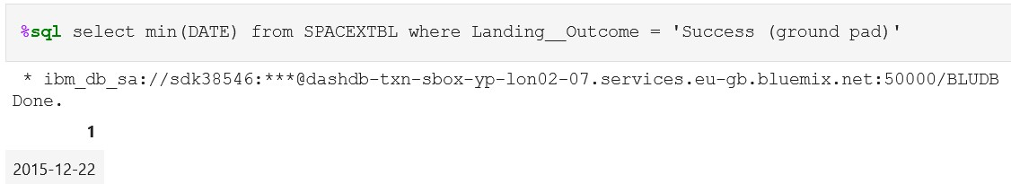

**Query**

Selecting only Booster_Version

The WHERE clause filters the dataset to Landing_Outcome

=

Success (drone ship

)

The AND clause specifies additional filter conditions Payload_MASS_KG

4000

AND Payload_MASS_KG

6000

Successful Drone Ship Landing with Payload between 4000

and 6000

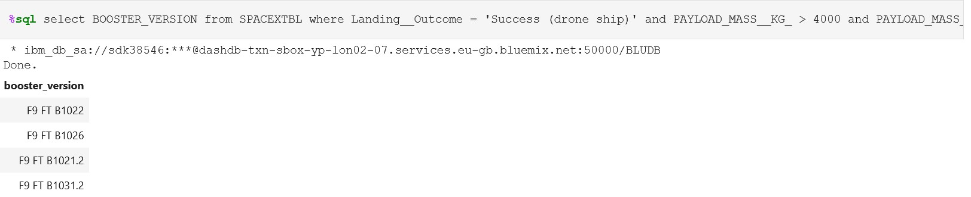

Calculate the total number of successful and failure mission outcomes

Total Number of Successful and Failure

Mission

Outcomes

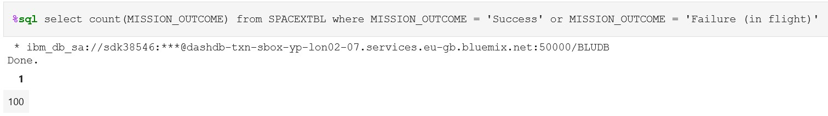

List the names of the booster which have carried the maximum payload

mass

Boosters Carried Maximum

Payload

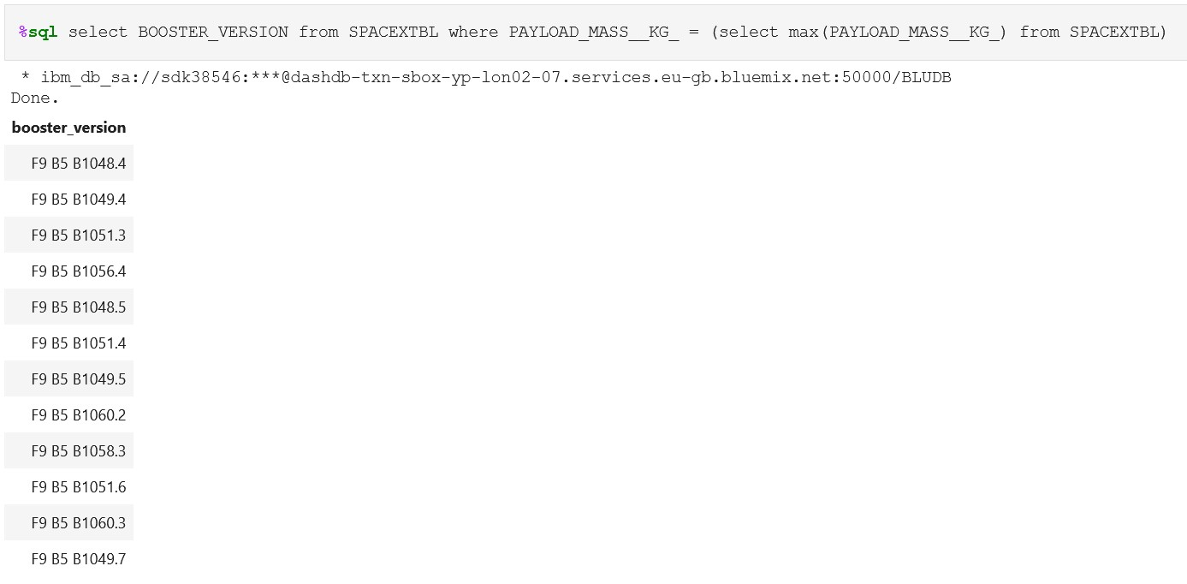

Rank the count of landing outcomes (such as Failure (drone ship) or Success

(

ground pad)) between the date 2010-06-04 and 2017-03-20, in descending

order

Rank Landing Outcomes Between 2010-06-04 and 2017-

03-20

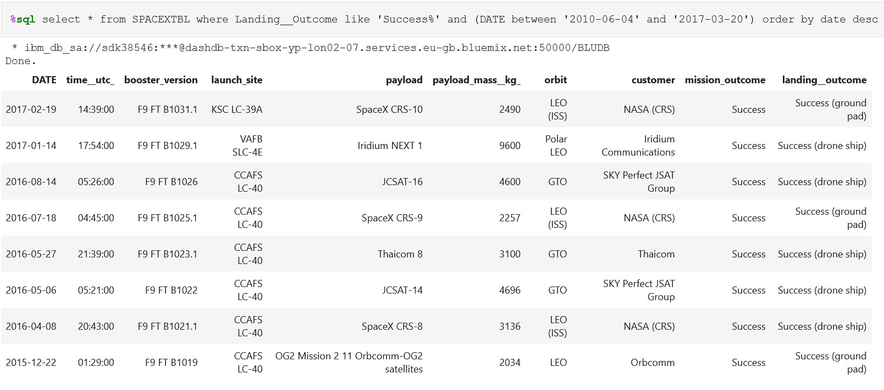

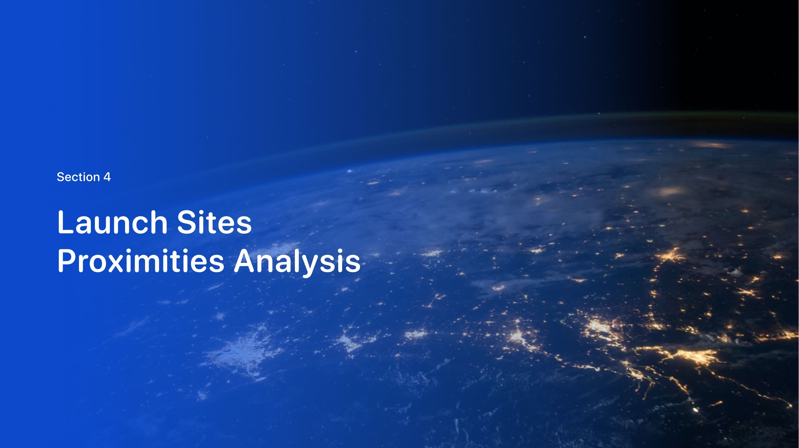



We can see that all launches are focused in CA and FL.

All Launch Sites

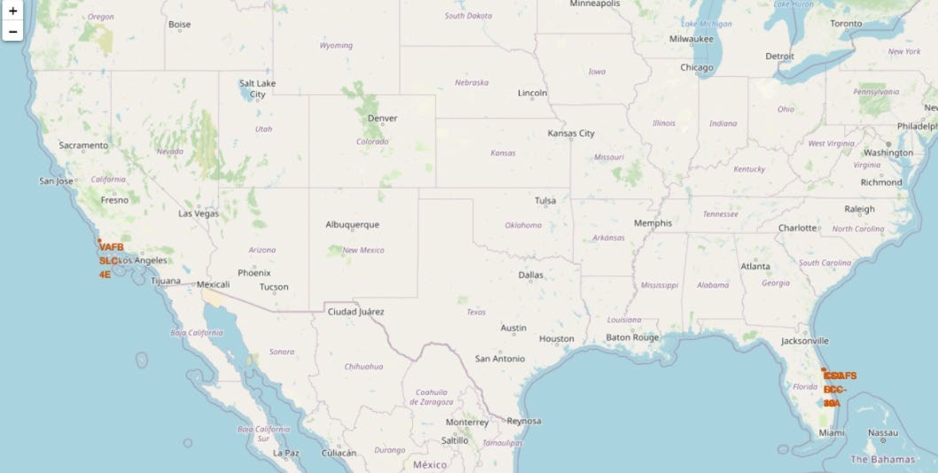

Exploring the map the

**successful**

landings are marked with a

**Green**

marker and

**Red**

for the

**unsuccessful**

landings

It was found that KSC LC-39A had more successful landings with

only 3 failures.

Launch Labeled Markers

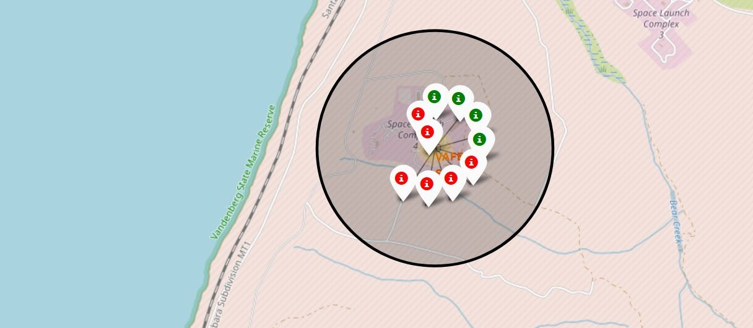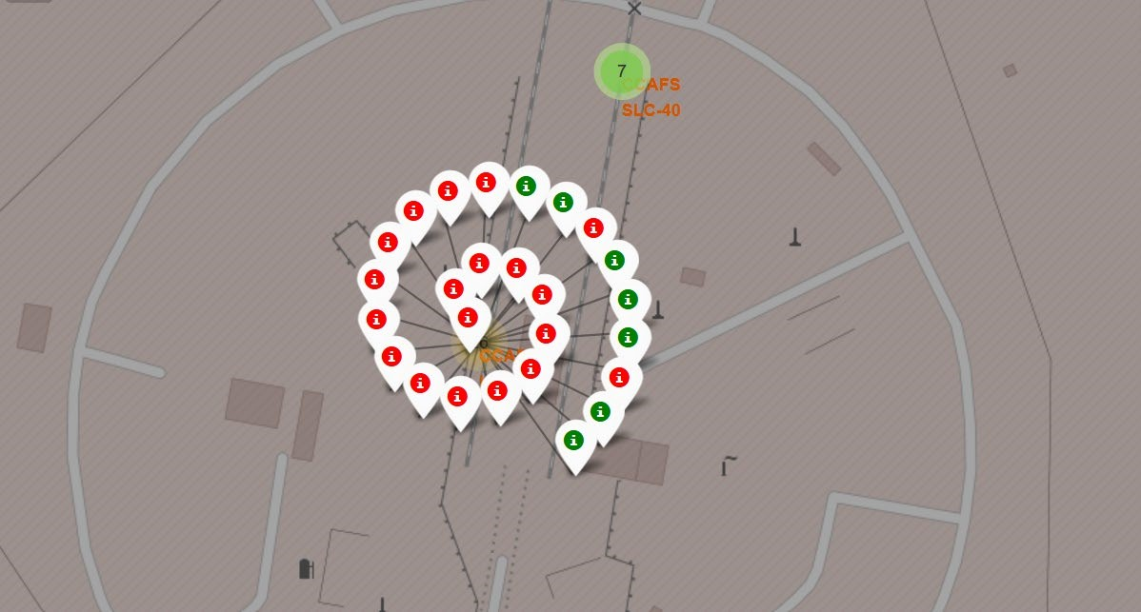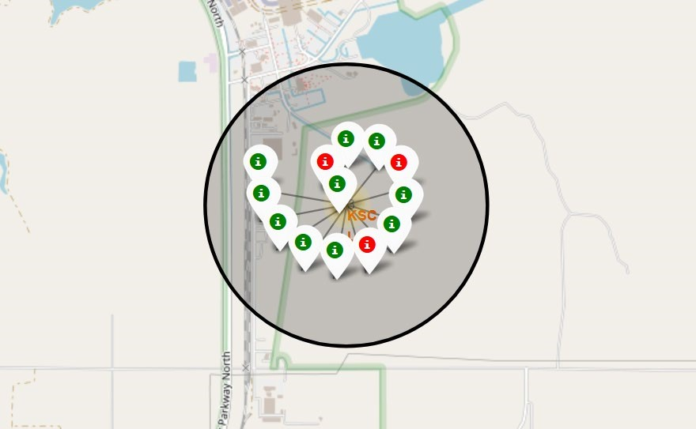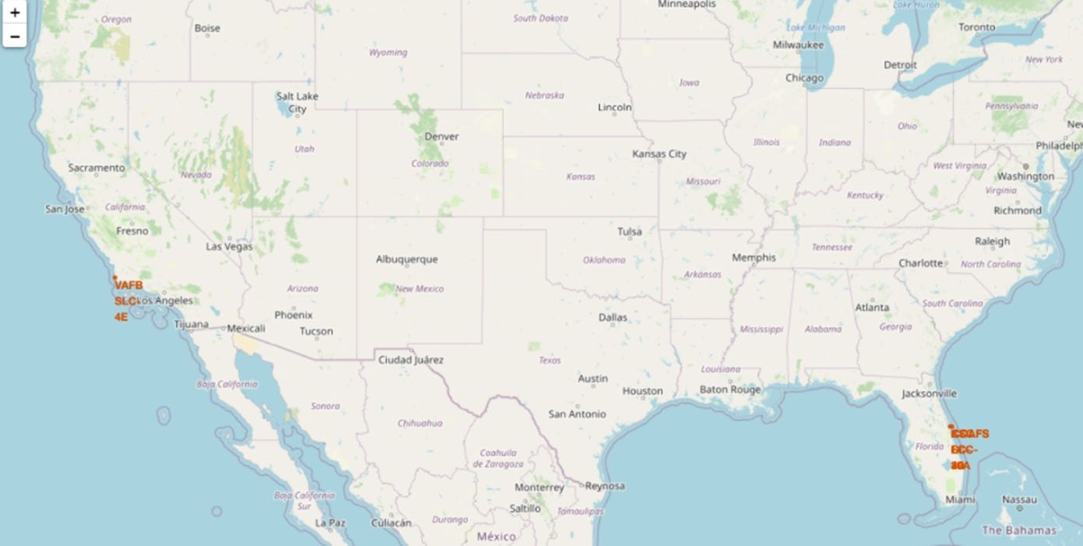

Landing site distances:

•

0.86

KM from the ocean

•

0.58

KM from the nearest road

•

1.28

KM from the Railroad

•

51.43

KM from the nearest

International Airport

Distances from the Launch Site

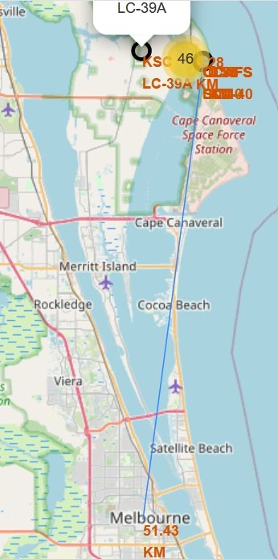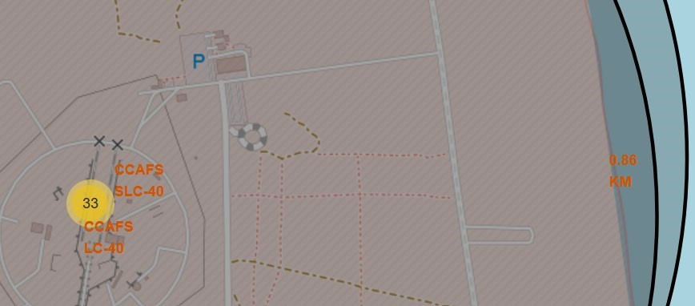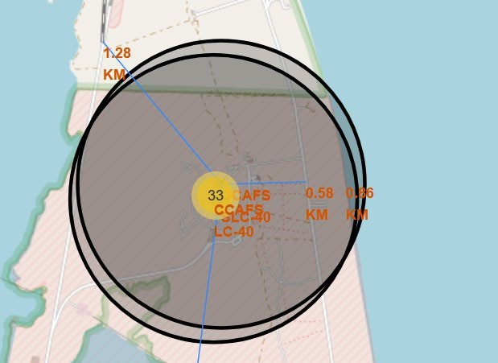

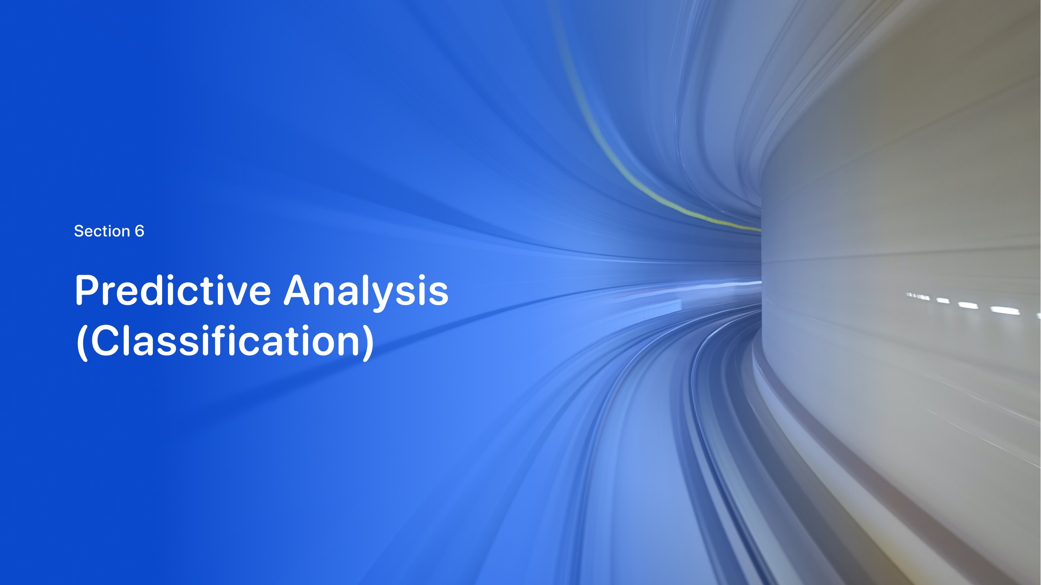



•

It was found that the Tree Algorithm

was the most accurate to predict this

data set.

Classification Accuracy

**Accuracy**

**Algorithm**

0.848214

KNN

0.889285

Tree

0.846428

Log. Regression

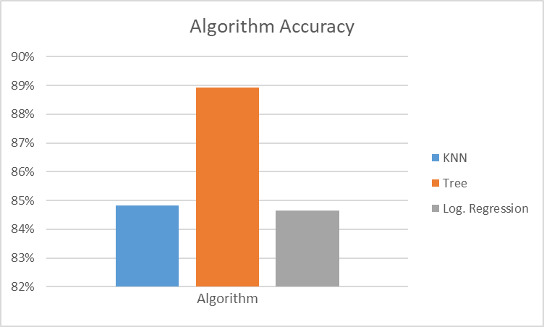

•

From the confusion matrix we can see tree algorithm does predict some

false positives in the data set.

Confusion Matrix

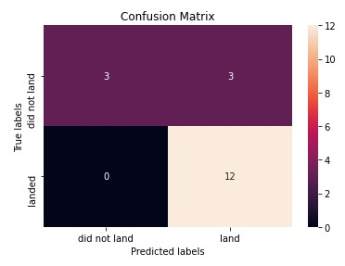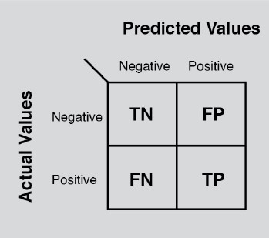

•

The best Classifier Algorithm was the Tree

Classifier with 0.889285 accuracy.

•

KSC LC-39A had more successful landings.

•

The Success Rate has increased over time.

•

ES-L1, GEO, HEO, and SSO

were the orbits with the

highest success rate.

Conclusions

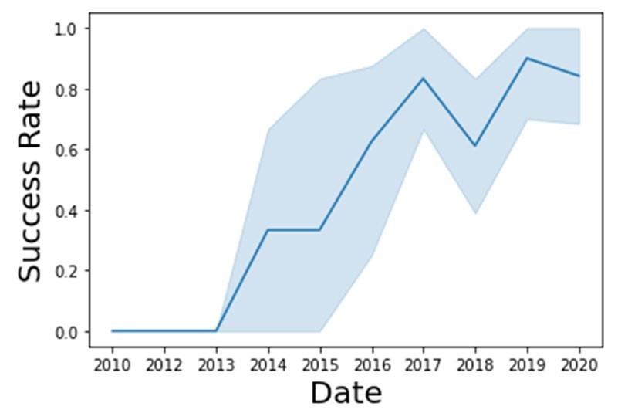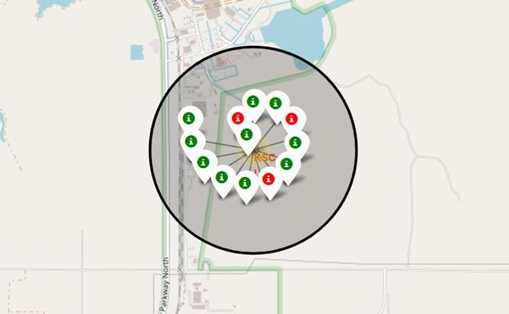

KSC LC-39A

